**DEVOPS ASSIGNMENT – 2**

**V. Dhanunjay**

**Creating AWS EC2 instance.**

1. Select the Launch instance on the top right side of the portal.

1. Give a name to the new EC2 instance that you are creating.

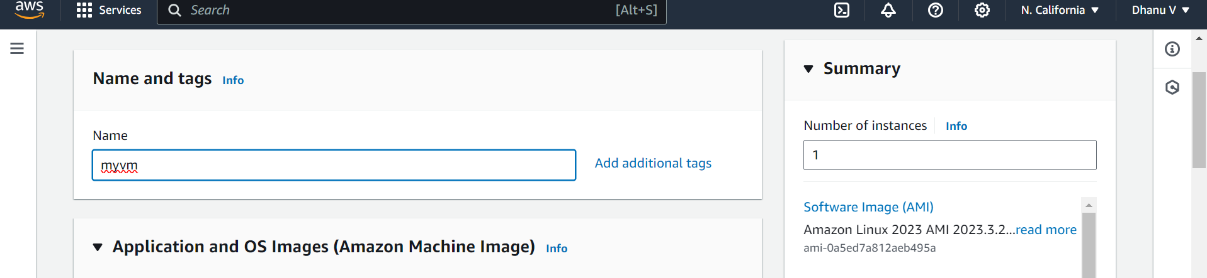

1. Select any operating system you want to launch. (Amazon linux or ubuntu is preferred).

As part of the free tier select the default AMI.

1. Select the instance type. It includes the CPU and the memory of the VM.

1. Create a key-pair to login into your system when you launch the instance.

Enter the key-pair name for security purposes. Select the default option for the key-pair type (RSA) .

For use with SSH portal from the computer, leave the default key file format to **.pem.**

1. Creating a security group for the networking. Leaving default will connect to the default subnet, automatically assigns the public ip address for the VM, and it allows the traffic through the SSH portal from anywhere. You can select the SSH port for high security.

1. Configure the system storage for the VM to store files and images.

(You can leave if you want to select the free tier option).

Review the instance configuration on the right hand side and launch the instance.

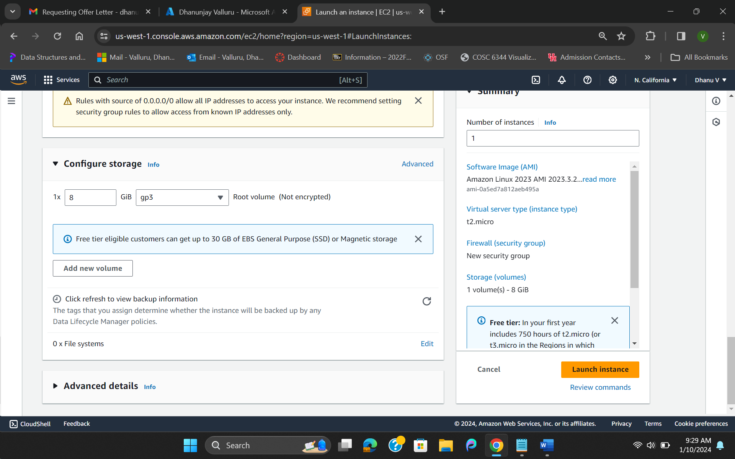

1. Created instance will appear in the EC2 dashboard.

1. In windows, open the Windows Powershell (Run it as administrator if SSH is not installed on your local system)
2. Run the following command by specifying the path of .pem file which previously downloaded key-pair. Also specify the ec2-username and the public DNS of the instance you have launched successfully.

*ssh -i /path/key-pair-name.pem instance-user-name@instance-public-dns-name*

If it ask you any fingerprint permissions, provide the access.

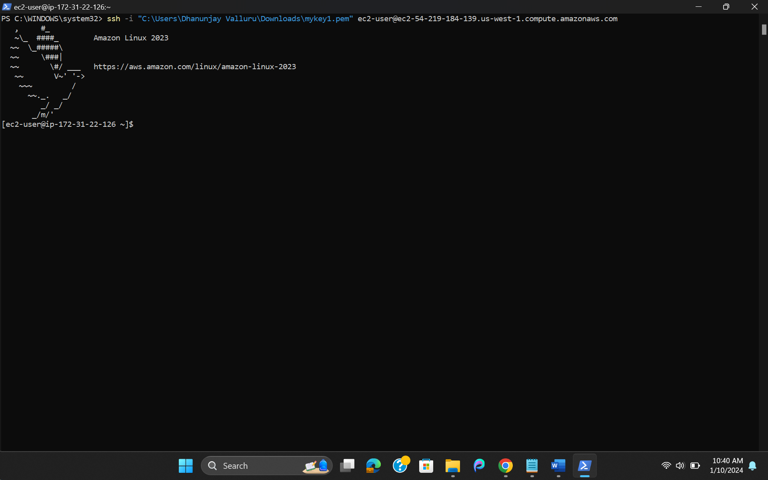

You are successfully connected to your Linux VM.